
MATHEMATICS APPLICATIONS
Investigation 3 Statistics, 2018

Section B – In Class Validation

Name: Solutions Marks: 37
Calculators allowed

Question One (4, 4 = 8 marks)
- Using Source Data 1
- Give the Mean, Median, Mode, Range, Standard Deviation and n (number of scores) for the ages of Females in the first 20 deaths.
- Create a box and whisker plot for the data.
$\overline{x}$ = 18.9 Med = 17 Mode = none Range = 42 S_{x} = 14.5 n = 8

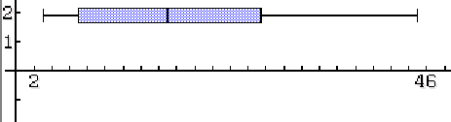

- Using Source Data 1
- Give the Mean, Median, Mode, Range, Standard Deviation and n (number of scores) for the ages of Males in the first 20 deaths.
- Create a box and whisker plot for the data.
$\overline{x}$ = 19.9 Med = 19 Mode = none Range = 36 S_{x} = 12.4 n = 12

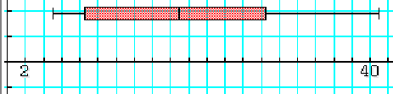

Question Two (4, 4 = 8 marks)
- Using Source Data 2
- Give the Mean, Median, Mode, Range, Standard Deviation and n (number of scores) for the ages of in Females for deaths 41 to 60.
- Create a box and whisker plot for the data.
$\overline{x}$ = 25.4 Med = 26 Mode = none Range = 42 S_{x} = 15.5 n = 5

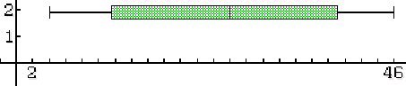

- Using Source Data 2
- Give the Mean, Median, Mode, Range, Standard Deviation and n (number of scores) for the ages of in Males for deaths 41 to 60.
- Create a box and whisker plot for the data.
$\overline{x}$ = 14.6 Med = 12 Mode = 4 Range = 34 S_{x} = 10.7 n = 15

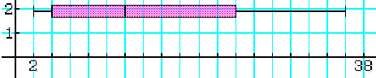

Question Three (4, 4, 3, 2 = 13 marks)
- From the statistics you calculated in Question One, compare the information you have found in part a) with part b) (deaths 1 to 20).
Explain what the results mean in the context of the situation rather than only saying
‘ value A is bigger or smaller than value B ’ .

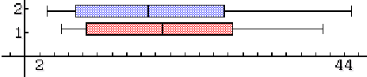
Compares centre (1) Explains what the centre means in context(1)
Compares spread (1) Explains what the spread means in context(1)

- From the statistics you calculated in Question Two, compare the information you have found in part a) with part b) (deaths 41 to 60).
Explain what the results mean in the context of the situation rather than only saying
‘ value A is bigger or smaller than value B ’ .

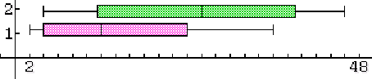

Compares centre (1) Explains what the centre means in context(1)
Compares spread (1) Explains what the spread means in context(1)

- Did your findings in part a) change when compared to your findings in part b) ?
Explain.

Yes. (1)
The male and female ages at deaths in the first 20 deaths are much more similar. The female ages were slightly lower and with a slightly bigger range.
In 41 to 60 deaths the females are much older however they are still have a slightly bigger range.
There are fewer females who died in the 41 to 60 deaths, three times as many males died compared to females. (1 - Explained poorly) (2 - Explained well)

- What conclusions can you make from part c) ?
Explain.
(2 - Explained well)

Question Four (4, 2, 2 = 8 marks)
The following Tally Table shows the distance from the Town Hall of each villager that died in the first 100 days.
First 100 Days Day 101 to 200
Km from town centre | Death Tally | Frequency of deaths
1 | IIII IIII lIII IIIl lIII llll IlII llll | 39
2 |  | 0
3 | I | 1
4 |  | 0
5 |  | 0
6 | I | 1
Total |  | 41
Km from town centre | Death Tally | Frequency of deaths
1 | IIII II | 7
2 | IIII III | 8
3 | I | 1
4 | l | 1
5 |  | 0
6 |  | 0
Total |  | 17

- What information can you gather from the tables above?
Compares centre (1) Explains what the centre means in context(1)
Compares spread (1) Explains what the spread means in context(1)

- What conclusions can you come to from the information above?
(1 - Explained poorly) (2 - Explained well)

- How can this information be relevant to containing the spread of disease today?
(1 - Explained poorly) (2 - Explained well)

